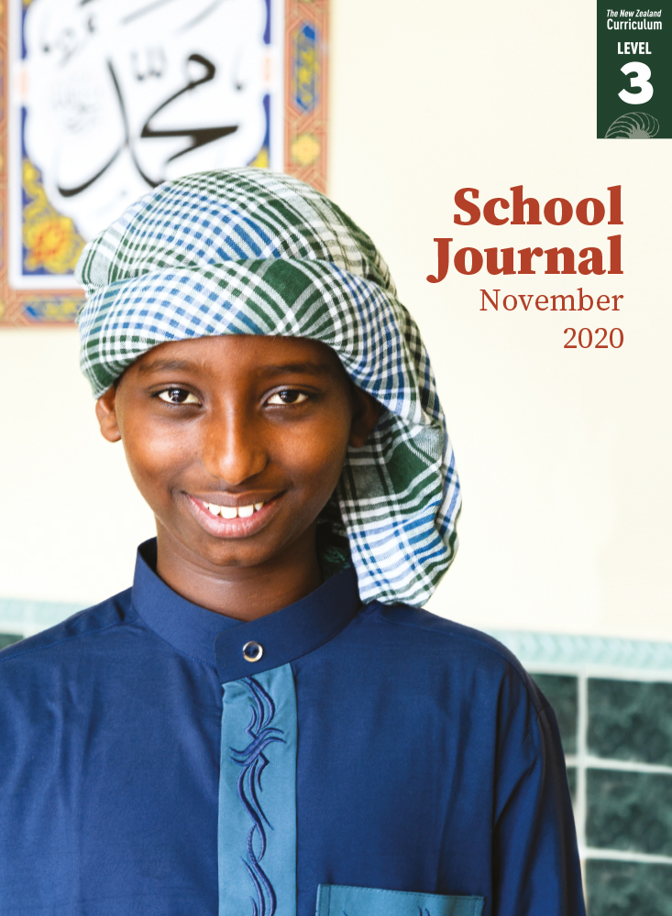

# All As One

by Susan Paris with Tahir Nawaz

School Journal

Level 3, November 2020

**Year 5**

The[Learning Progression Frameworks](https://curriculumprogresstools.education.govt.nz/lpf-tool/) describe significant signposts in reading and writing as students develop and apply their literacy knowledge and skills with increasing expertise from school entry to the end of year 10.

## Overview

While Muslims account for a small percentage of New Zealand’s population, their community has had a high profile in recent years. This article provides a brief introduction to the community’s values, as seen through the eyes of four people involved with the Kilbirnie and Hāwera mosques.

A PDF of the text is available at [www.schooljournal.tki.org.nz](http://www.schooljournal.tki.org.nz)

## Themes

|  |  |  |  |
| --- | --- | --- | --- |
| * Values | * Community | * Diversity | * Inclusiveness |

## Related texts

**“Home”** SJSL L3 June 2018| **“Ramadan Is Coming”** SJ L2 Aug 2013 | **“My Name Is Rez”** SJ L3 Nov 2017 |   
**“New New Zealanders”** SJ L3 June 2017

## Strengthening reading behaviours (what to notice)

|  |  |
| --- | --- |
| Text structure and features | Requiring students to: |
| * Abstract ideas  *Sharing a language unites us; when people are hurting, we stand together by their side; a community that stretches beyond her own* * Figurative language *these details fall away shoulder to shoulder* * Quotes integrated into the running text | * integrate the overall context and information from the surrounding text with prior knowledge of conversational language and familiar sayings to understand the intended meaning * as above * attend carefully to punctuation to identify who is speaking and to differentiate quotes from the writer’s words. |

|  |  |
| --- | --- |
| Vocabulary | |
| Many proper nouns  Words in Arabic (glossed)  Other possibly challenging words | Wellington, Kilbirnie, Somalia, Egypt, Ethiopia, Pakistan, India, Malaysia,  Indonesia, China, Japan, Cambodia, Bangladesh, Syria, Asia, Europe, Bosnia, Afghanistan, Kosovo, Iran, Iraq, Auckland, Queenstown, Hāwera, Arabic, Qur’an,  Islam, Koran, Ramadan, Eid, English, Somali, Tahir Nawaz, Maria, Sharmake Ahmad,  Anthony Horowitz  Arabic, Qur’an, Islam, Ramadan, Eid, imam, surah, hijab  solidarity, separately, generations, diversity, unity, sermons, Muslims, spokesperson, responsibilities, promote, decades |

|  |
| --- |
| Helpful prior knowledge (pre-reading and introducing the text) |
| * Mosques are places of worship for Muslim people. * Many New Zealand cities and towns have mosques. * Ramadan is a special time for Muslim people and it involves fasting. * Muslim people come from a wide variety of countries, from all continents around the world. |

## Possible reading and writing purposes

* Identify what is important to the young Muslim people interviewed in the story
* Describe some of the cultural practices explained in the article
* Explain the many purposes mosques have for Muslim people.

See *Effective Literacy Practice in Years 5–8* for information about teaching comprehension strategies ([Teaching comprehension](https://literacyonline.tki.org.nz/Literacy-Online/Planning-for-my-students-needs/Effective-Literacy-Practice-Years-5-8/Teaching-comprehension))   
and for suggestions on using this text with your students ([Approaches to teaching reading](https://literacyonline.tki.org.nz/Literacy-Online/Planning-for-my-students-needs/Effective-Literacy-Practice-Years-5-8/Approaches-to-teaching-reading)).

## Possible curriculum contexts

This text has links to level 3 of *The New Zealand Curriculum* in: [**ENGLISH**](http://nzcurriculum.tki.org.nz/The-New-Zealand-Curriculum/English) [**SOCIAL SCIENCES**](https://nzcurriculum.tki.org.nz/The-New-Zealand-Curriculum/Social-sciences)

## Understanding progress

The following aspects of progress are taken from the [Learning Progression Framework](https://curriculumprogresstools.education.govt.nz/lpf-tool/)s and relate to the specific learning tasks below. See the LPFs for more about how students develop expertise and make progress in these aspects:

* Acquiring and using information and ideas in informational text
* Making sense of text: using a processing system; using knowledge of text structure and features; vocabulary knowledge;   
  reading critically
* Reading to organise ideas and information for learning; Using writing to think and organise for learning
* Creating texts to communicate current knowledge and understanding.

## Strengthening understanding through reading and writing

**Select from the following suggestions and adapt them** according to your students’ strengths, needs, and experiences.   
Note: Most of these activities lend themselves to students working in pairs or small groups.

* Ask the students to share their response with a partner. *What was something new that you found out? What was something you already knew? What surprised you? What do you want to find out more about? Did anything challenge the way you thought?*
* Prompt the students to make connections to their prior knowledge by asking questions (*Who knows another language or has a family member who knows another language?*) or by using a graphic organiser such as the **Tic-tac-toe** template at the end of this TSM to record nine things that interested them. Have them share and justify their responses, noting what was the same and what was different.
* The author has introduced four people. Unpack what the things they say tell us about them. Have pairs or small groups of students focus on one person and record information such as who the person is, where they are from, what they say, what they do, what’s important to them, and what they want for the future. Bring the students back together to create a chart (for example, a Venn diagram) to find commonalities between the four, and then, together, come up with a sentence that summarises how a mosque meets the needs of the people in its community.
* Have the students discuss things they noticed about the mosque from the photographs (for example, people sit on the floor, some people wear a hijab, shoes are removed, there are different patterns and colours of carpet). *What inferences can you make about the mosque and its community from the photographs?*
* Discuss the author’s choice of title. *The title of the article is “All As One”. Why do you think the author chose this? What else could the article be called?*
* Support the students to explore the abstract ideas in the text, such as “sharing a language unites us”, “a community that stretches beyond her own”, “people come here to learn and pray”, “when people are hurting, we stand together by their side”, and “these details fall away”. Have the students draw a T-chart and write the abstract phrases from the text in the left-hand column. In the right-hand column, have them write in their own words what they think the phrase means. The students could then share their charts and discuss any differences to clarify their understanding.
* Have each student pick a word that was challenging to say or understand. Pull out any common ones and discuss these as a class.
* Ask the students to write a response to the article. You could give them starter sentences, such as: I think mosques …; I didn’t know …; I would like to …; I have …; Something that I learnt is that …; I already knew …; My experience of mosques is …
* Alternatively, have the students write about a place that is important to them or something they do with others that gives them a sense of community and belonging (for example, guides or soccer).

|  |
| --- |
| **“All As One” Tic-tac-toe** |

In each square, write one thing from “All As One” that you didn’t know or that you found interesting or surprising   
(9 things altogether).

